# Guidelines for React Native Setup

## Step 1: Download the installation files from the Internet

Start the browser of your PC and the latest version of React Native framework that is to be installed is searched.

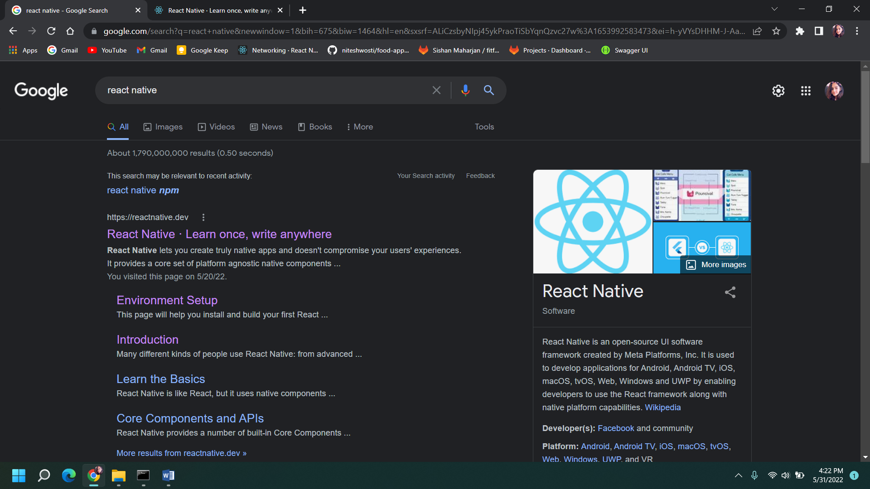

Search for the environment setup installation guidelines.

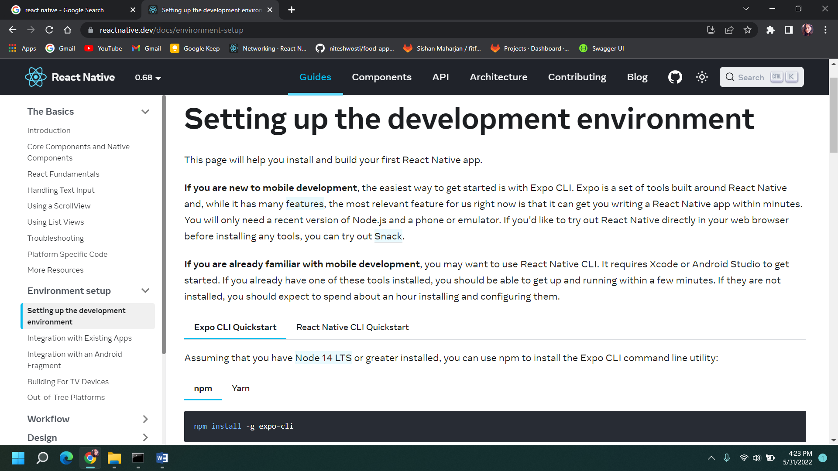

## Step 2: Using npm install the Expo CLI command line utility

Using the command below, the installation of expo cli begins.

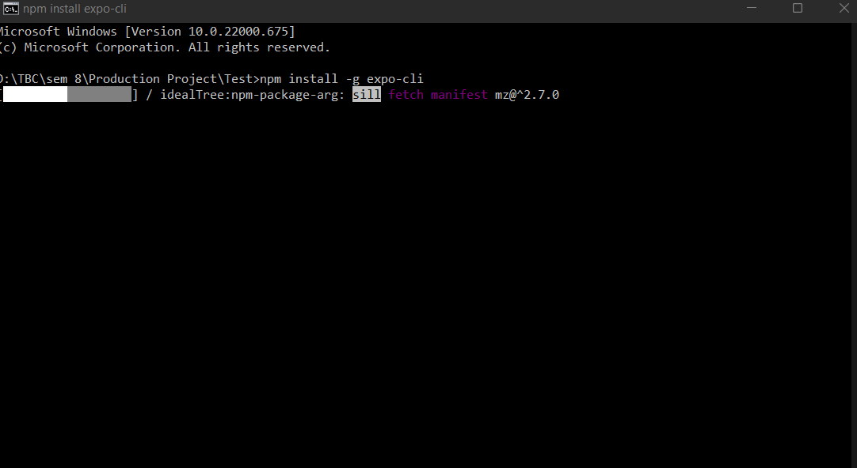

## Step 3: Create a react-native project

This creates a new react-native project called Fitfood.

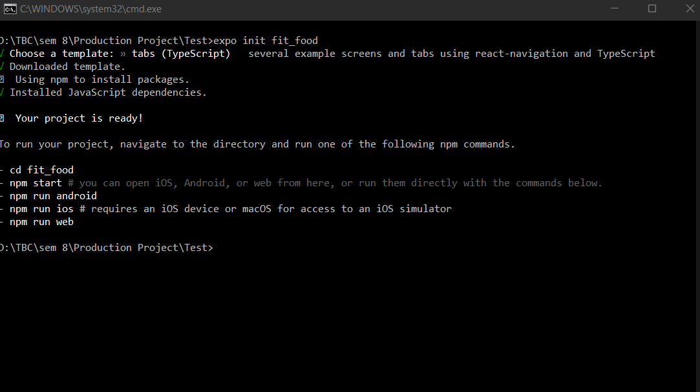

## Step 4: Installing npm package in the react-native folder

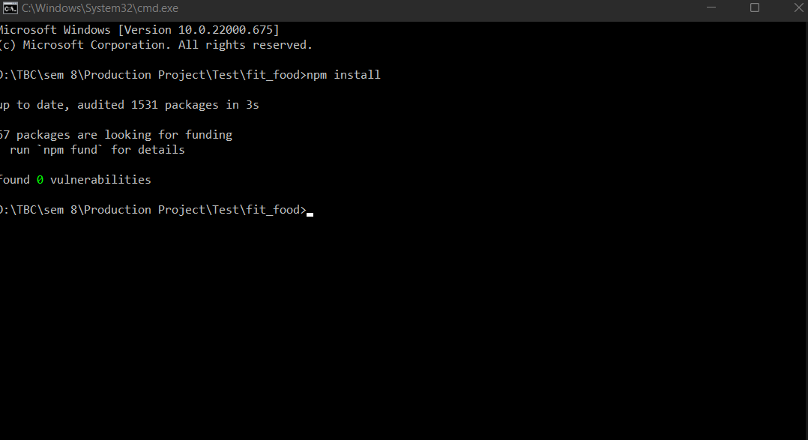

## Step 5: Start Metro

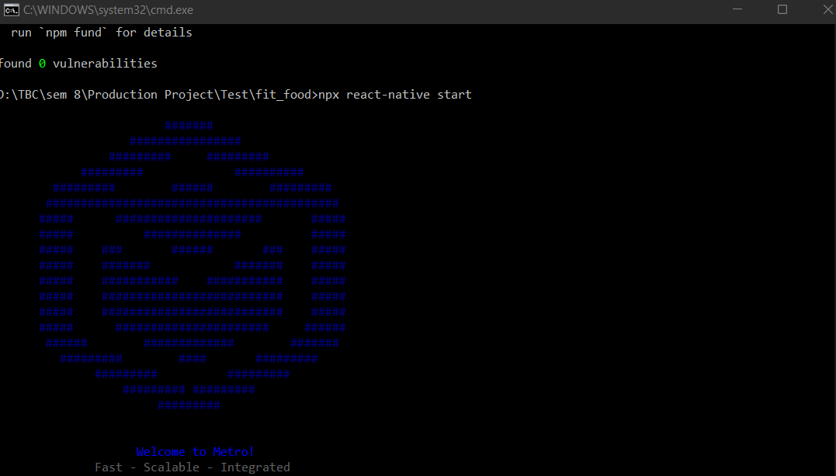

## Step 6: Start the emulator to run the project in VS-Code

